Lab 5:
- Write SQL code to display Employee records whose name begin with ‘p’.
- Display records whose name end with ‘e’.
- Display records whose name start with ‘k’ and end with ‘l’.
- Display records whose address contains substring ‘pur’.
- Display records whose name starts with ‘s’ and ends with ‘a’ and Address is ‘Kantipur’.
SQL Queries:
- CREATE DATABASE Gaurav;
- USE Gaurav;
- CREATE TABLE Employee (
eid INT PRIMARY KEY,
eName VARCHAR (100),
Address VARCHAR (100),
Gender VARCHAR (10),
Salary VARCHAR (100)
);

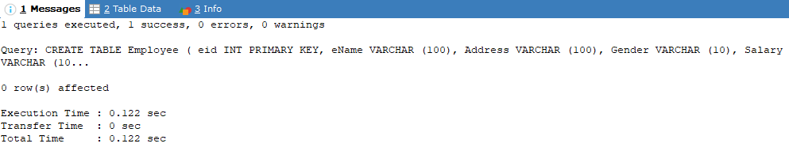

- INSERT INTO Employee VALUES
(1,'Abilekh','Mustang','Attackhelicopter',69300),
(2,'Alisha','KTM','Male',23000),
(3,'Anshu','Mustang','Female',27000),
(4,'Kamal','Mustang','Male',40000),
(5,'Aslesha','Kanchanpur','Female',19000),
(6,'Sara','Kantipur','Female',12000);
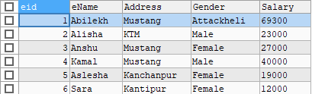

- To display records whose name begins with ‘p’.

SELECT *FROM Employee WHERE ename LIKE 'p%';

- To display records whose name end with ‘e’.

SELECT *FROM Employee WHERE ename LIKE '%e';

- To display records whose name start with ‘k’ and end with ‘l’.

SELECT *FROM Employee WHERE ename LIKE 'k%l';

- To display records whose address contains substring ‘pur’.

SELECT *FROM Employee WHERE Address LIKE '%pur%';
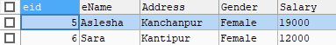

- To display records whose name starts with ‘s’ and ends with ‘a’ and Address is ‘Kantipur’.

SELECT *FROM Employee WHERE ename LIKE 's%a' AND Address='Kantipur';

Lab 6:
- Create table customer and insert datas.
- Display data whose address is Ayush Address.
- Display information whose buying amount is Gaurav purchase amount.
- Display all distinct phone numbers.
SQL Queries:
- CREATE DATABASE lab6;
- USE lab6;
- CREATE TABLE customer(
Cid INT(3) PRIMARY KEY NOT NULL,
Cname VARCHAR(30),
Caddress VARCHAR(30),
BuyingAmount NUMERIC,
Phone NUMERIC
);
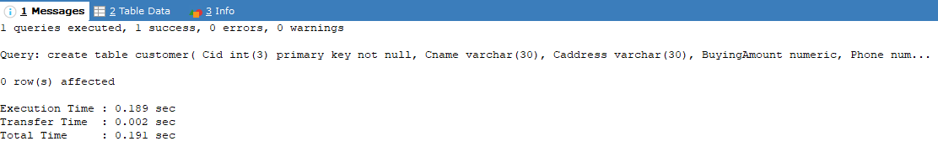

- INSERT INTO customer VALUES
(101,'Abilekh','Mustang',13500,9842776302),
(102,'Alsiha','KTM',1500,9842776302),
(103,'Anshu','KTM',500,9841276302),
(104,'Anush','Gorkha',13500,9843776302),
(105,'Aslesha','KTM',10000,9845776302),
(106,'Ayush','Patan',13000,9878776302),
(107,'Barsha','Lamjung',12000,9882776302),
(108,'Gaurav','KTM',13500,9842776302),
(109,'Diya','Bkt',13500,9847876302)
;
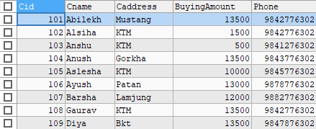
- To display data whose address is Ayush Address.

SELECT *FROM customer WHERE Caddress=(SELECT Caddress FROM customer WHERE Cname='Ayush');
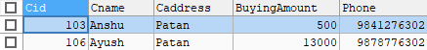

- To display information whose buying amount is Gaurav purchase amount.

SELECT *FROM customer WHERE BuyingAmount=(SELECT BuyingAmount FROM customer WHERE Cname='Gaurav');
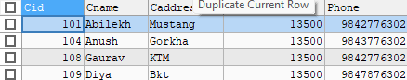

- To display all distinct phone numbers.

SELECT DISTINCT Phone FROM customer;
